***Abstract: Students face a problem in boarding college bus on time .To do it more easy for them here is a project that will help to know the location of the college bus.***

COLLEGE BUS TRACKING

***Hence we decided to come up with ‘College Bus Tracking’ .It is a useful tracking system with raspberry pi, GPS module and fire base service .It will make students easy to know the location of college bus.***

***The vehicles movement will be tracked by the students parents and even by the institutes .Every student transportation involves careful routing and schedule of trips .These should be done carefully so that the students reach their destination on time and of course safely.so with this GPS tracking and the app associated with firebase software can help students, parents and the institute to know bus movement details.***

***Keywords: Raspberry pi, Students.***

1. **INTRODUCTION**

Students who are going to colleges will face difficulty in catching the bus, they exactly don’t know at which time the bus will arrive to their stops because of traffic jams and other issues .Every student will face bus related issue in the early morning ,sometimes students will not go to colleges by these kind of bus issues. In our project we use GPS to the buses, to see the GPS location of the college buses. We make users to see the college buses GPS location in their mobile, by this ’**COLLEGE BUS** **TRACKING**’ students can reach college on time without any troubles and they can see their college buses GPS location ,so that they can manage time and be ready in their bus stops.

1. **LITERATURE REVIEW**

**1.Bus Tracking System Using GPS on Smart phones**

The system is composed of many pieces, tools, and interfaces:

1.The website

2.The android app

3.The API

4.The service alerts web app

They have used all these pieces, tools, and interfaces to develop the bus tracking system using GPS on smart phones.

**2.Real Time College Bus Monitoring and Notification System**

Components

1.GPS Tracker

2. ESP8266 Micro controller

3.MySQL Database

4.Mobile Application

They have developed this with the help of IOT and android studio. This can track the bus activity and makes

to converse more time and work efficiently. And the disadvantage is that the accuracy of the device is still be tested and it may cause problem accordingly to the service and device maintenance.

1. **COMPONENTS USED**
2. **Raspberry pijkj**

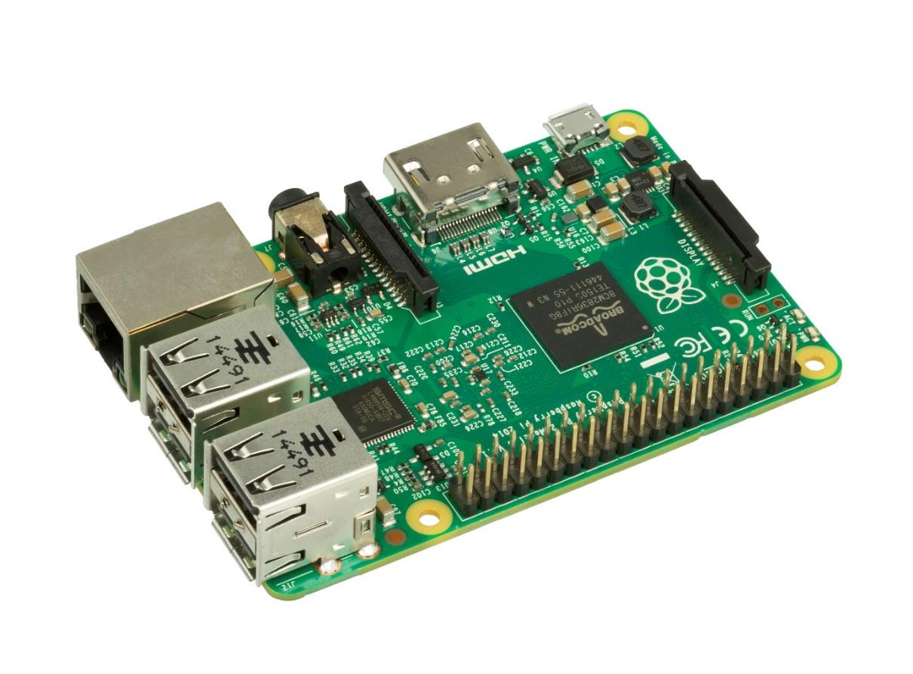

* The Raspberry pi is a low cost, credit-card sized computer.
* The raspberry pi has a tool to create or to communicate by sending and receiving the

information.

1. **GPS Module**

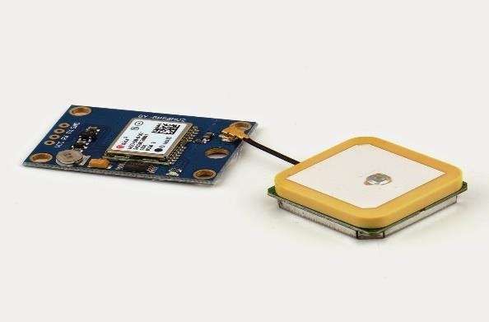

* This GPS module helps to give coordinates of longitude and latitude.
* This module is connected to raspberry pi to send information to the server, about the location of the bus.

1. **SOFTWARE SPECIFICATIONS**

In this prototype, the application was built with the help of java and xml coding which is done in android studio to develop the mobile application. The tracking device coding was done with the help of python and these two are combined in the fire base server respectively.

1. **PROPOSED SOLUTION**

By connecting raspberry pi ,GPS module and firebase service to the bus module we know the exact location of college buses by using app in mobile.

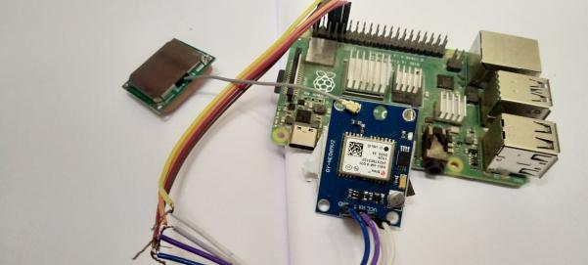

GPS transmit location co-ordinates. Raspberry pi reads the transmission data from GPS module and raspberry pi send location data to the server. For every 3 seconds raspberry pi sends location data to server, application is developed by android studio, in android studio java language is used. The application reads the data from the server(firebase). Then the application shows the location coordinate in the map.

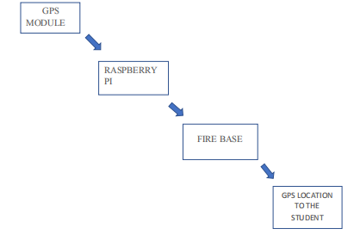

1.GPS transmit location co-ordinates.

2.Raspberry pi reads the transmission data from GPS module and raspberry pi send location data to the server.

3.for every 3 second raspberry pi sends location data to server.

4.application is developed by android studio, in android studio java language is used.

5.the application reads the data from the server(firebase).

6.then the application shows the location coordinate in the map.

1. **ADVANTAGES**

* Students are able to get the college bus location data.
* They can manage time with this information.

**VII. DISADVANTAGES**

* It may be difficult to get accurate location but will get the approximate location of the bus.
* May not be suitable for network issue areas.

**VIII. CONCLUSION**

With the help of firebase service when the student want to know the location of the college bus, firebase service with the help of GPS module connected to the raspberry pi students can able to find the location of the college bus.

The complete software and hardware which are used in this project is explained in the above headings. As mentioned firebase services used it is one of the effective that have made the task of the app developers simpler to much extent. It not only helps in the development process, but also offers variable solutions to reach out more targeted customers do comprehension app marketing and enhance the app revenue. This

project can be applied in all collage and school buses. The cost practical application is very less and designing a model for this Unit is easy. The simulation model is constructed.

**ACKNOWLEDGEMENT**

We thank all our faculty members and Lab Assistants for their valid support. We own all our success to our beloved parents, whose vision, love and inspiration has made us reach out for these glories.

**REFERENCE**

1. R.BalaKrishnan,” Mobile Application for College Bus Tracking”, , International Journal of Computer Science and Mobile Computing.
2. Mr. Pradip Suresh Mane,” Analysis of Bus Tracking System Using GPS on Smartphones**”** June 2016;IOSR Journal of Computer Engineering.
3. B.DhivyaBharathy,” GPS/GSM Based Bus Tracking System (BTS)”, International Journal of Scientific & Engineering Research, Volume 4, Issue 12, December-2013.
4. Manash Pratim Gohain, Speed Governors, GPS must for school buses, The Times of India, February 24, 2017.
5. Yuanqing Zheng; Pengfei Zhou; Mo Li, "How Long to Wait? Predicting Bus Arrival Time with Mobile Phone Based Participatory Sensing, "Mobile Computing, IEEE Transactions on, vol.13, no.6, pp.1228, 1241, June 2014.
6. Rahman, A. A., & Sidek, S., Abdullah, A. R., "The critical flaw in the implementation of GPS tracking system in express bus industry," 10th IEEE Int. Conf. Serv. Oper. Logist. Informatics, SOLI 2015 - conjunction with ICT4ALL 2015, pp. 71–76, 2015.